

**INFORMATION AND COMMUNICATIONS UNIVERSITY**

**DEPARTMENT OF ICT**

**ICT PROJECT**

**FINAL YEAR PROJECT – PROGRESS REPORT**

*A Final year project progress report Submitted in Partial fulfilment for the Bachelor’s Degree in Information and Communication Technology with Education*

**NAME : PHIRI ISAAC**

**SIN : 1511966807**

**PROGRAM : BED ICT**

**TITLE : CONSTRUCTION OF AND NTRUSIONDETECTION SYSTEM BY USING INFRARED SENSORS FOR HOME AND OFFICE USE : *A Case Study Of Urban School in***

***Lusaka District***

The following is a Report progress so far for the construction of an intruder detection system using infrared sensors for Home and office use – a case study of Schools in Lusaka urban district.

This system consists of three modules namely:

* Administration
* Teacher on duty
* Security

**1.0.0 Administration**

-This module handles all operations in this system. Such as managing users, generating reports, arming the alarm as well as disarming the alarm. The administration can also check for activity logs and errors.

The general overview of the front end of the system is as shown on figure 1 below.

**Figure 1**

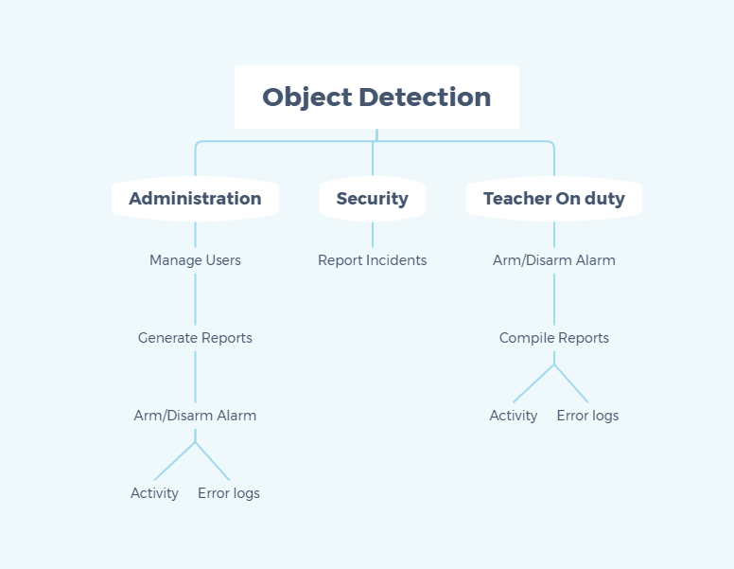

**Teacher on Duty**

The teacher on Duty will have the following privileges on the system; Arm the system, compile reports, View activity logs and system errors as well as disarm the alarm. As seen in diagram 2.

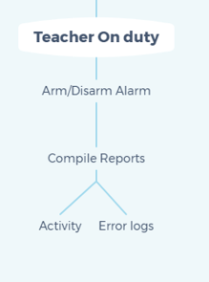

**Figure 2**

**Security**

The role of the security personell in this system is monitor the premises physically and to send reports in case there is any incident in the premises being managed in this case being a school premises. As shown on diagram 3.

